Erin Mandell

September 29, 2019

PyCitySchools Report

The PyCitySchools exercise yielded results that I am both surprised and dismayed to see. Surprised because it so obviously confirmed my opinion about Charter schools that I thought was potentially true (though I hadn’t looked into the data). And dismayed due to the implications for most students at non-Charter public schools.

1. Test score results don’t change much over time. The scores a student achieves on average are remaining constant throughout their high school years.

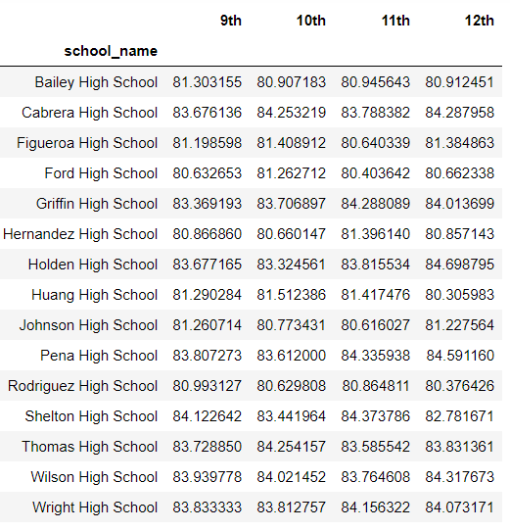

1. School spending per pupil seems to have minimal, if any, impact on student performance. A weakness of this particular chart is that it doesn’t address the reality that much of the spending in non-Charter schools is directed toward special needs students. What we see at this point in the analysis is that spending *seems* to have an inverse relationship to performance.

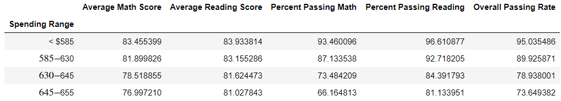

1. Things start to get interesting with this chart, where we learn that student performance seems to be correlated with school size. Both the test score and the passing rate measures decrease as the school size increases.

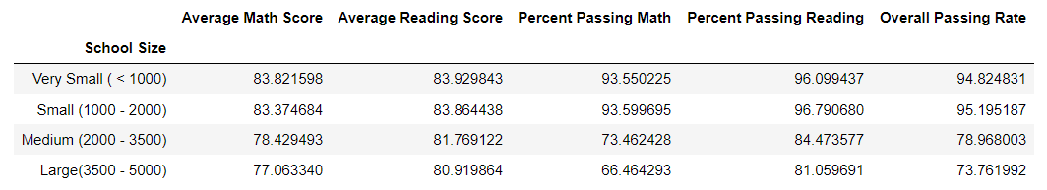

1. The performance by School Type chart is the most revealing piece of information that the homework assignment yields us. We see clearly that - *on average* – students at the Charter schools perform better in both the test score and passing rate measures. What we do not see here, of course, is the breakdown of performance of special needs vs non-special needs students within the non-Charter sphere. It may very well be that a significant number of students without special needs are performing quite will at these schools.

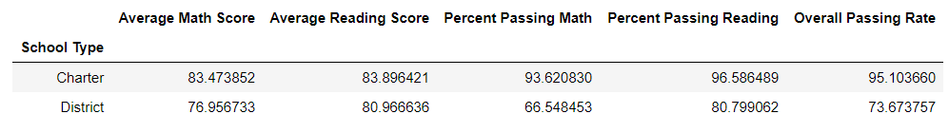

1. A question that immediately came to mind for me was whether or not the small schools and charter schools were actually the same…. I put together one more chart with a dual sort – first by Type, then by Total Students. The results are fascinating. What we learn here is that Charter schools are smaller, spend less, and perform dramatically better (again – on average).

